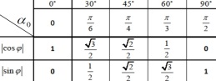  
Im z = y /// Re z = x  
ALGEB/KART: z = z + iy  
TRYG: z = |z|(cosφ + i\*sin φ)  
WYKŁAD: z = |z| \* e i \* φz = x + iy z = re i \* φ   
 = x – iy $\overline{z}$ = re - i \* φ   
|z| = |z| = r  
(a-b)3 = a3-3a2b+3ab2-b3a3-b3 = (a-b)(a2+ab+b2)